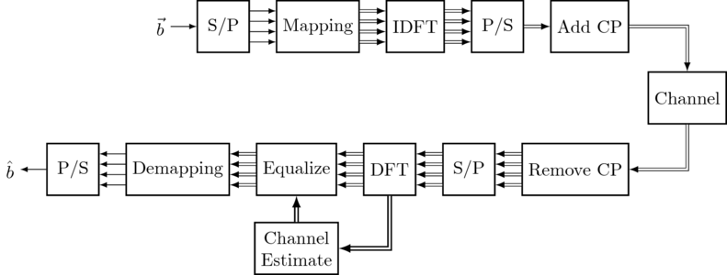

*OFDM has developed into a popular scheme for* [*wideband*](https://en.wikipedia.org/wiki/Wideband)[*digital communication*](https://en.wikipedia.org/wiki/Digital_communication)*, used in applications such as digital television and audio broadcasting,* [*DSL*](https://en.wikipedia.org/wiki/Digital_subscriber_line)[*internet access*](https://en.wikipedia.org/wiki/Internet_access)*,* [*wireless networks*](https://en.wikipedia.org/wiki/Wireless_network)*,* [*power line networks*](https://en.wikipedia.org/wiki/Power-line_communication)*, and* [*4G*](https://en.wikipedia.org/wiki/4G)*/*[*5G*](https://en.wikipedia.org/wiki/5G) *mobile communications*[*[1]*](https://en.wikipedia.org/wiki/Orthogonal_frequency-division_multiplexing#cite_note-ergen-1)*.*

So Mohammed introduced the Alamouti code.

And today I would like to talk about the specifics of each process of OFDM.

As we can see of this graph, the upper is T and the lower is R.

As we have the data, which is a sequence of bits, I use b to represent that.

b: random bit sequence.

S/P : serial to parallel converter, which groups the bits for the OFDM frame into a group of bits.

Mapper: mapper converts the groups into complex-valued constellation symbols according to the mapping table.

right before we do Discrete Fourier Transform

between Mapping and IDFT: do the allocation of different subcarriers with data and pilots.

Which I will explain the reason later.

For each subcarrier we have defined whether it carries data or a pilot by the arrays . Then we create the overall OFDM data, and put the data and pilots into the OFDM carriers.

IDFT: inverse discrete fourier transform, convert the signal from the frequency domain to the time domain. using FFT function here

CP: cyclic prefix

This operation concatenates a copy of the last CP samples of the OFDM time domain signal to the beginning.

So when cp is added, it can eliminate the ISI, intersymbol interference when an OFDM signal is transmitted in a dispersive channel.

when it is being convoluted, the cp is like a guard interval

A Cyclic Prefix extends the length of each symbol beyond just that of one IFFT length so that the IFFT can be (hopefully) done over a portion of the signal past where all the orthogonal subcarriers have been messed up with multipath echoes. Because when data is transmitting from different paths, it may have delays. Skipping past the messed up portion allows the (constant or otherwise) channel response to be mostly ignored by the receiver, while maintaining the orthogonality of all the subcarriers from each other.

But it is still possible that when CP is not long enough, it cannot completely eliminate intersymbol interference and the detection performance will become even worse.

So people have already figured out the method that how we decide the length of CP which is on the channel model used for a specific standard. As an example, in 802.11a the length of CP is one quarter of an OFDM symbol

So we then send the data thro channels and now we come to the receiver side.

On the receiver side, most of the process is just inverse of the transmitter side.

But there are still some differences between them which I would like to talk about,

Channel estimation:

As we know in all communication the signal goes through a medium (called channel) and the signal gets distorted or various noise is added to the signal while the signal goes through the channel. if we want to properly decode the received signal without much errors, we have to remove the distortion and noise applied by the channel from the received signal. To do this, the first step is to figure out the characteristics of the channel that the signal has gone through. So this is channel estimation.

we set up a 'reference signal' or 'pilot signal', just like i mentioned in the transmitting part we added pilot signal into our data. So it is sort of like the example that prof wang told us in one meeting, a pilot signal is like a white t shirt, and after the receiver side catch the

pilot signal', it will know how distorted this signal is, like if the white t shirt turns into a yellow one, you might know that when you receive an orange t shirt, it could probably used to be a red one based on the pilot signal. So that's basically how people do channel estimation and eliminate most of the errors base on this method,

So this is what I got about the specifics of each process of OFDM. And Mohammed took over the coding part, and I think he would like to talk about his MATLAB code of OFDM.

some src

<https://www.youtube.com/watch?v=rKy5dOl3Et4>

<http://www.sharetechnote.com/html/Communication_ChannelEstimation.html>

<https://dspillustrations.com/pages/pages/courses/course_OFDM/html/03%20-%20Basic%20OFDM%20modulation%20and%20demodulation.html>

<https://www.mathworks.com/help/lte/ug/channel-estimation.html>

https://zh.wikipedia.org/wiki/%E6%AD%A3%E4%BA%A4%E9%A0%BB%E5%88%86%E5%A4%8D%E7%94%A8